Statistical Reporting and Frequently Asked Questions

Churches and presbyteries can access the year-end statistics online reporting system.
Go to the Online Statistics Entry system.
*The system works best with Firefox, Google Chrome and Safari.
*If you need further assistance contact your Presbytery or email OGARecords@pcusa.org.

Where can I find my user name and/or password?
Contact your presbytery for information related to your user name or password.

My user name and password are not working.
Be sure that you are using five (5) numbers for your user name. The user name for a church is the PIN number. You will need to add leading zero’s if your PIN is fewer than five numbers. Example, you PIN number is 123. The user name would be 00123.
The passwords are also case sensitive. The letter O and number zero 0 often look the same, as well as the letter I and the number one 1. If one does not work try the other.

When I log in there is no tab labeled “Statistics.”
In most cases, this is an issue with the browser you are using. We suggest using Firefox for best results.

What is the deadline date for entering statistics?
Contact your presbytery for information. Presbyteries establish their own deadline. John Calvin Presbytery’s deadline is Feb. 10, 2020.

Do I have to enter everything at one time?
No. Hitting the ‘Accept’ button on the bottom of a page saves the data. You may exit and return to enter additional pages at a later time.

How do I print a copy of my report?
You have two options.
On the main screen when you first log into the program, above your church address area you will see a button that says “PDF.” Pressing this will create a copy of your current year report as a PDF.
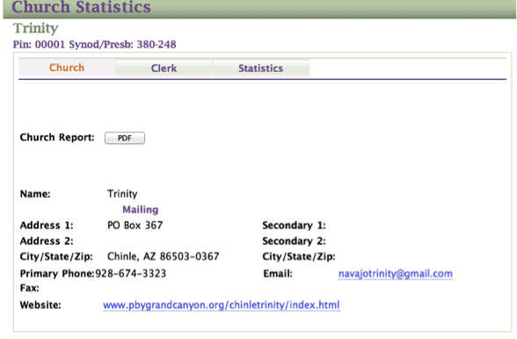

The other option:
After logging into the program, on the right side, you’ll see the option Reports. Below is the portion of the workbook (page 5) explaining how to print.
To print or download a copy of your report press the option “Reports.” You’ll need to work through a series of options.
To view or print a copy choose “Church Report.” It will then ask you for the year you would like to view.

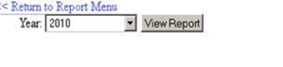
Your report will appear in a box, scroll down to view page one, then use the blue arrow buttons on the top of the page to move to the second page. To print a page use the drop down box that reads “Select a Format.” I suggest using the Acrobat (PDF) option for a clean copy of your report. Press the Export button to download your desired format.
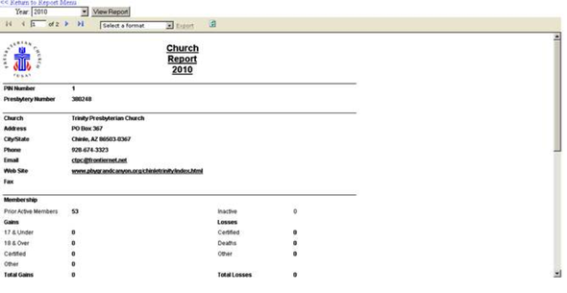

Who do I contact if I have a problem?
Call your presbytery for immediate help (Beth Kick at 417-425-7604 or bkick@jpresbytery.com) or email OGARecords@pcusa.org for additional help.

